Adventure Works Internet Sales and Business Growth
Case Study Report Assignment 2
Christina Fan
University of Pennsylvania
Course 6070
Submission date: October 27 2026

Executive Summary
Adventure Works recorded 29,358,677.22 in Internet sales across 60,398 order lines and 18,484 purchasing customers. Bikes generated 96.46% of revenue, with an average realized unit price of 1,862.42. Complete-year sales fell 17.43% in 2012, then increased 179.87% in 2013. The United States and Australia were the largest 2013 markets. Leadership should protect bike availability and test accessory and clothing cross-selling, beginning with targeted campaigns in these markets. Homeowners spent more per observed customer, but the unadjusted comparison does not establish causation. The 2010 and 2014 extracts cover partial years.

1 Introduction
Adventure Works leadership needs evidence to guide growth in its Internet business. This report examines sales across years, country regions, and product categories; summarizes customer income and gender; and compares purchasing patterns by home ownership. The supplied file contains 60 original attributes and transactions dated December 29 2010 through January 28 2014.
All amounts are expressed in the dataset’s recorded monetary units. The file contains several CurrencyKey values but does not provide currency labels, exchange rates, or a data dictionary confirming monetary conversion. The analysis therefore sums SalesAmount as supplied; country comparisons should be confirmed against the company’s reporting-currency definitions before budget allocation.

2 Analytical Goals and Decision Criteria
SalesAmount is the principal revenue measure; tax and freight are reported separately in the source and are not added. Revenue is summarized by order year, customer country region, and inferred product category. Customer-level summaries count each CustomerKey once. Growth priorities are assessed using observed revenue scale, category mix, spending per customer, and the feasibility of a measurable pilot. Advertising costs, site visits, and campaign outcomes are unavailable, so conversion rates and marketing returns cannot be estimated.

3 Data Preparation and Analytical Approach
The accompanying Python notebook uses pandas and Matplotlib and follows the supplied Week 7 example with numbered explanatory text cells before each code cell. The CSV is read with Latin-1 encoding, OrderDate is converted to a date, and Year is extracted. All 60,398 order lines are retained. There are no repeated SalesOrderNumber and SalesOrderLineNumber combinations and no missing values in the principal analytical fields. Missing names, address details, tracking numbers, and purchase-order numbers are not needed for the analysis.
There are 27,659 orders and 18,484 purchasing customers. Country, gender, yearly income, and home ownership are consistent within each CustomerKey. Income and gender summaries use one record per customer to avoid weighting frequent buyers more heavily. Income standard deviations are sample standard deviations. Gender is categorical, so it is summarized using counts and percentages rather than numerical minima, maxima, or standard deviations.
No product category field is supplied. Names beginning Road-, Mountain-, or Touring- identify Bikes; names containing Cap, Jersey, Gloves, Shorts, Socks, or Vest identify Clothing; the remaining observed products are Accessories. The notebook displays the complete mapping. These are analyst-defined categories inferred from names, rather than a verified company category lookup. Every order line has quantity one, so realized revenue per unit equals the average transaction UnitPrice in this extract.

4 Data Analysis

4.1 Internet Sales by Year and Country Region
Sales totaled 7,075,525.93 in 2011, 5,842,485.20 in 2012, and 16,351,550.34 in 2013. Revenue decreased 17.43% from 2011 to 2012 before increasing 179.87% in 2013. The extract includes only December 29–31 in 2010 and January 1–28 in 2014. Their low totals must not be interpreted as full-year declines. Appendix A reports every year and country region.
In 2013, the United States generated 5,462,078.86 and Australia generated 4,339,443.38. Together they contributed 59.94% of that year’s sales. The United Kingdom followed at 2,124,007.29. All six country regions increased revenue from 2012 to 2013. These observed changes do not identify whether customer acquisition, product availability, or other business conditions caused the growth.

4.2 Product Categories and Average Price
Bikes generated 28,318,144.65, or 96.46% of total revenue, from 15,205 units. Accessories generated 700,759.96 and Clothing generated 339,772.61. Accessories led unit volume, with 36,092 units, but their much lower prices produced a smaller revenue contribution. Thus the highest-revenue category differs from the highest-volume category.
The category mix also changes across the extract: 2011 contains only bike sales, and the partial 2014 period contains no bike sales. These patterns could reflect product coverage or availability as well as demand, so category comparisons cannot by themselves explain growth.
The average realized price in Bikes, the highest-revenue category, was 1,862.42 per unit, calculated as total bike SalesAmount divided by total bike OrderQuantity. This is a sales-weighted transaction measure, not an unweighted catalog price. Appendix B reports category totals and category sales by year. The observed concentration supports protecting the bike offering while testing complementary sales; it does not prove that any specific bundle will increase spending.

4.3 Customer Income and Gender by Country Region
Mean yearly income among purchasing customers was highest in Australia (64,338.62) and lowest in France (35,762.43). Country means describe this customer base and should not be treated as national income estimates. Appendix C gives the minimum, maximum, mean, and sample standard deviation for each country and each country–gender group.
The customer base includes 9,133 F records (49.41%) and 9,351 M records (50.59%). Both recorded genders are represented at similar proportions within each country. These summaries do not support restricting marketing by gender or assuming individual willingness to pay from country income averages. Income is recorded as supplied; cross-country purchasing-power differences are not adjusted.

4.4 Home Ownership and Sales
Homeowners generated 20,385,349.80 from 12,502 customers, while non-homeowners generated 8,973,327.42 from 5,982 customers. The larger homeowner group explains much of the total-revenue difference. Normalizing for group size, revenue per customer was 1,630.57 for owners and 1,500.05 for non-owners, a difference of 8.70%. Revenue per order was 1,069.65 versus 1,043.29.
The observed customer-level difference is modest relative to the total-sales difference. Home ownership is associated with spending in this extract, but income, country, product choice, and observation length may differ between groups. Only purchasing customers are observed, so the data cannot establish whether homeowners are more likely to buy, nor whether owning a home causes greater spending. No adjusted regression or significance test is used. Appendix D provides all comparison measures.

5 Preferred Alternative with Rationale
The preferred strategy is to protect the bike business while piloting relevant accessory and clothing recommendations at product pages and checkout. Bikes account for nearly all recorded revenue, making bike availability, product information, and a reliable checkout experience immediate priorities. Lower-priced complementary products provide a plausible cross-selling opportunity, although the benefit must be tested rather than assumed.
A blanket bike discount could reduce revenue or margin without evidence of additional demand. Targeting only homeowners would overstate a modest unadjusted difference and overlook non-owner customers. A limited cross-selling pilot preserves a broad customer audience while directly testing whether complementary recommendations improve revenue per order. The United States and Australia offer large existing revenue bases for initial market-specific tests; campaign costs and reporting-currency consistency should be verified before committing budgets.

6 Recommendations and Predicted Outcomes
First, check availability and checkout performance for the bike products contributing the most revenue. Second, test compatible accessories and clothing alongside bike purchases, using a randomized comparison where feasible. Third, compare market-specific creative and product recommendations in the United States and Australia, then evaluate smaller markets based on incremental results rather than historical growth rates alone.
Track revenue per order, add-on attachment rate, contribution margin after discounts and campaign costs, returns, and customer conversion using newly collected traffic data. Compare results with a control group over the same period. Intended outcomes are additional complementary purchases and higher profitable revenue per order without reducing bike conversion. The current dataset cannot predict a numerical uplift; expansion should depend on measured incremental performance.

7 Conclusion
Adventure Works’ observed Internet revenue is concentrated in Bikes and in the United States and Australia. Complete-year growth rebounded strongly in 2013, while partial boundary years limit trend interpretation. Customer summaries show a modest homeowner spending difference but no causal basis for ownership-based targeting. A measured cross-selling pilot, supported by a reliable bike purchase experience, is the most defensible next step from these descriptive findings.

References
Adventure Works Bicycle Company. InternetSales (1)(2).csv. Dataset supplied with Case Study Report Assignment 2. No additional source metadata provided.

Appendix A Annual Sales by Country Region
2010 covers December 29–31; 2014 covers January 1–28. Full calendar years are available for 2011–2013. Amounts are in recorded monetary units.
Table A1 Internet sales by country region in 2010 and 2011
Country | 2010 | 2011
Australia | 20,909.78 | 2,563,732.25
Canada | 3,578.27 | 571,571.80
France | 3,399.99 | 410,845.33
Germany | 0.00 | 520,500.16
United Kingdom | 699.10 | 550,591.22
United States | 14,833.90 | 2,458,285.17
Source: Author calculations from the supplied InternetSales CSV. Values are rounded for display.
Table A2 Internet sales by country region in 2012 to 2014
Country | 2012 | 2013 | 2014
Australia | 2,128,407.46 | 4,339,443.38 | 8,507.72
Canada | 307,604.52 | 1,085,632.65 | 9,457.62
France | 648,065.54 | 1,578,511.80 | 3,195.06
Germany | 608,657.98 | 1,761,876.36 | 3,277.83
United Kingdom | 712,700.96 | 2,124,007.29 | 3,713.64
United States | 1,437,048.73 | 5,462,078.86 | 17,542.85
Source: Author calculations from the supplied InternetSales CSV. Values are rounded for display.
Table A3 Total Internet sales by year
Year | Sales
2010 | 43,421.04
2011 | 7,075,525.93
2012 | 5,842,485.20
2013 | 16,351,550.34
2014 | 45,694.72
Source: Author calculations from the supplied InternetSales CSV. Values are rounded for display.

Appendix B Product Category Sales
Table B1 Revenue and units by category
Category | Revenue | Units | Share percent
Accessories | 700,759.96 | 36,092 | 2.39
Bikes | 28,318,144.65 | 15,205 | 96.46
Clothing | 339,772.61 | 9,101 | 1.16
Source: Author calculations from the supplied InternetSales CSV. Values are rounded for display.
Table B2 Category sales by year
Year | Accessories | Bikes | Clothing
2010 | 0.00 | 43,421.04 | 0.00
2011 | 0.00 | 7,075,525.93 | 0.00
2012 | 2,147.08 | 5,839,695.33 | 642.79
2013 | 668,241.53 | 15,359,502.36 | 323,806.45
2014 | 30,371.35 | 0.00 | 15,323.37
Source: Author calculations from the supplied InternetSales CSV. Values are rounded for display.
Average realized bike price = 28,318,144.65 / 15,205 = 1,862.42. Categories are inferred from product names; the notebook lists the mapping.

Appendix C Customer Income and Gender
Table C1 Yearly income by country region
Country | N | Mean | Min | Max | SD
Australia | 3,591 | 64,338.62 | 10,000 | 170,000 | 31,830.00
Canada | 1,571 | 57,167.41 | 10,000 | 170,000 | 20,251.52
France | 1,810 | 35,762.43 | 10,000 | 110,000 | 27,277.40
Germany | 1,780 | 42,943.82 | 10,000 | 130,000 | 35,493.58
United Kingdom | 1,913 | 52,169.37 | 10,000 | 170,000 | 48,431.99
United States | 7,819 | 63,616.83 | 10,000 | 170,000 | 25,706.48
Source: Author calculations from the supplied InternetSales CSV. Values are rounded for display.
Table C2 Yearly income by country region and gender
Country | Gender | N | Mean | Min | Max | SD
Australia | F | 1,777 | 65,284.19 | 10,000 | 160,000 | 31,164.36
Australia | M | 1,814 | 63,412.35 | 10,000 | 170,000 | 32,450.71
Canada | F | 767 | 56,505.87 | 10,000 | 170,000 | 19,181.55
Canada | M | 804 | 57,798.51 | 10,000 | 170,000 | 21,214.77
France | F | 893 | 35,341.55 | 10,000 | 110,000 | 26,915.85
France | M | 917 | 36,172.30 | 10,000 | 110,000 | 27,633.45
Germany | F | 874 | 43,810.07 | 10,000 | 130,000 | 35,715.76
Germany | M | 906 | 42,108.17 | 10,000 | 130,000 | 35,277.49
United Kingdom | F | 934 | 52,184.15 | 10,000 | 170,000 | 48,288.44
United Kingdom | M | 979 | 52,155.26 | 10,000 | 170,000 | 48,593.22
United States | F | 3,888 | 63,276.75 | 10,000 | 170,000 | 25,166.56
United States | M | 3,931 | 63,953.19 | 10,000 | 170,000 | 26,228.43
Source: Author calculations from the supplied InternetSales CSV. Values are rounded for display.

Appendix C Customer Income and Gender Continued
Table C3 Recorded gender distribution by country region
Country | F count | M count | F percent | M percent
Australia | 1,777 | 1,814 | 49.48 | 50.52
Canada | 767 | 804 | 48.82 | 51.18
France | 893 | 917 | 49.34 | 50.66
Germany | 874 | 906 | 49.10 | 50.90
United Kingdom | 934 | 979 | 48.82 | 51.18
United States | 3,888 | 3,931 | 49.73 | 50.27
Source: Author calculations from the supplied InternetSales CSV. Values are rounded for display.
N refers to unique purchasing customers. F and M are the source labels. Income SD uses the sample formula with denominator N minus one. No numerical mean, minimum, maximum, or SD is assigned to the categorical Gender field.

Appendix D Home Ownership Comparison
Table D1 Revenue and group sizes
HouseOwnerFlag | Revenue | Customers | Orders
Non-owner | 8,973,327.42 | 5,982 | 8,601
Owner | 20,385,349.80 | 12,502 | 19,058
Source: Author calculations from the supplied InternetSales CSV. Values are rounded for display.
Table D2 Normalized spending
HouseOwnerFlag | Per customer | Per order
Non-owner | 1,500.05 | 1,043.29
Owner | 1,630.57 | 1,069.65
Source: Author calculations from the supplied InternetSales CSV. Values are rounded for display.
Owner-minus-non-owner revenue per customer is 130.51, or 8.70% relative to non-owners. Comparisons cover the entire observed period and are unadjusted for different purchase dates or customer characteristics.

Appendix E Analysis Figures
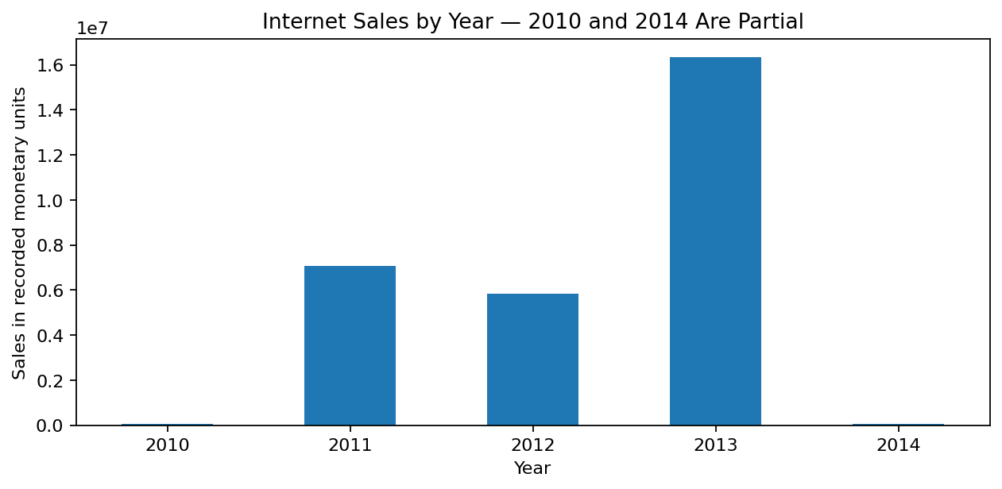
Figure E1 Annual Internet sales. The 2010 and 2014 observations are partial years.
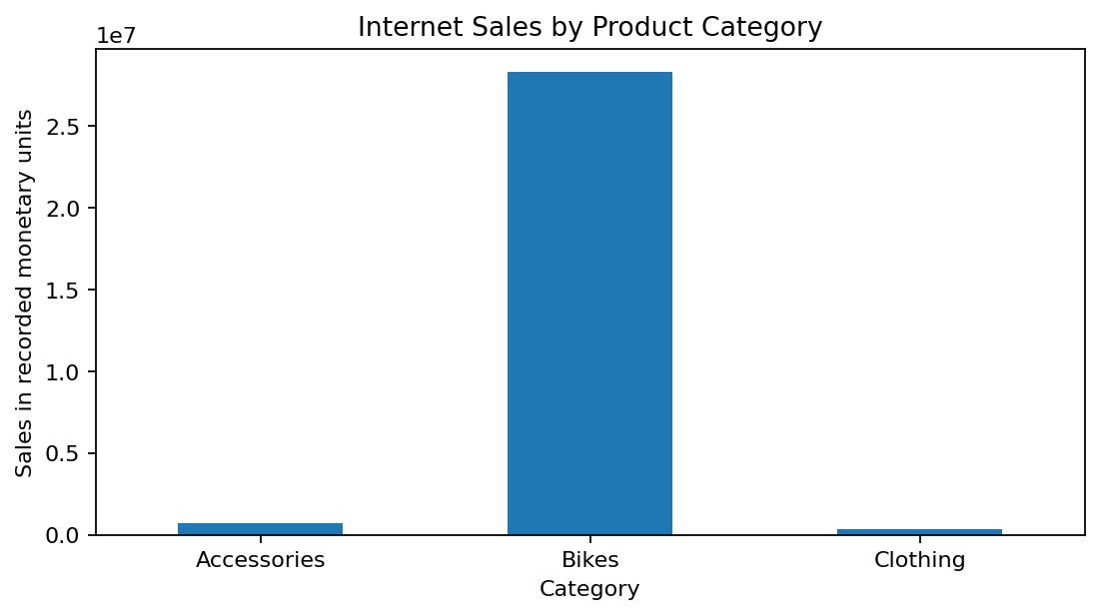
Figure E2 Internet revenue by inferred product category. Bikes lead revenue, while Accessories lead units sold.

